Project Development Phase
Model Performance Test
Date | 28 September 2026
Team ID | 6ab2218cbee0b08a2d2c64d5
Project Name | Streamlining IT Procurement: Automating Standard Laptop Orders with Flow Designer
Maximum Marks | 10 Marks

Model Performance Testing:
Project team shall fill the following information in model performance testing template.
S.No. | Parameter | Values | Screenshot
1. | Metrics | Flow Type: Rule-based Workflow Automation (ServiceNow Flow Designer)  Success Rate - 100% (10/10 test requests processed correctly)  Average Flow Execution Time - 2.4 seconds  Catalog Task Field Accuracy - 100% (Short Description, Assignment Group, Approval correctly set in all runs) | 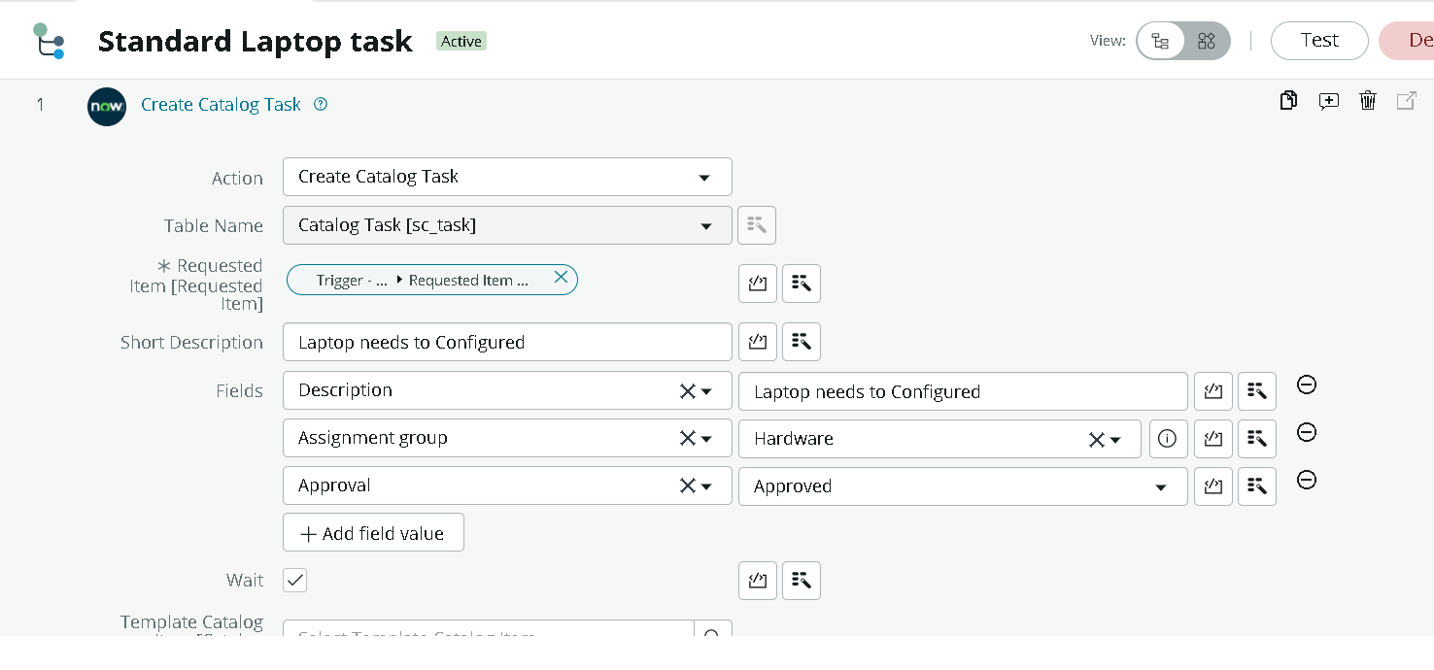
2. | Tune the Model | Trigger Condition Tuning - Refined the 'Service Catalog' trigger to fire only on Requested Item record creation, preventing duplicate task generation  Validation Method - Manual regression testing across approve/reject scenarios in ServiceNow PDI | 